**WEEK 4 HandsOn**

**1 - Create a Spring Web Project using Maven**   
  
**TASK :**

1. Go to <https://start.spring.io/>
2. Change Group as “com.cognizant”
3. Change Artifact Id as “spring-learn”
4. Select Spring Boot DevTools and Spring Web
5. Create and download the project as zip
6. Extract the zip in root folder to Eclipse Workspace
7. Build the project using ‘mvn clean package -Dhttp.proxyHost=proxy.cognizant.com -Dhttp.proxyPort=6050 -Dhttps.proxyHost=proxy.cognizant.com -Dhttps.proxyPort=6050 -Dhttp.proxyUser=123456’ command in command line
8. Import the project in Eclipse "File > Import > Maven > Existing Maven Projects > Click Browse and select extracted folder > Finish"
9. Include logs to verify if main() method of SpringLearnApplication.
10. Run the SpringLearnApplication class.

SME to walk through the following aspects related to the project created:

1. src/main/java - Folder with application code
2. src/main/resources - Folder for application configuration
3. src/test/java - Folder with code for testing the application
4. SpringLearnApplication.java - Walkthrough the main() method.
5. Purpose of @SpringBootApplication annotation
6. pom.xml
   1. Walkthrough all the configuration defined in XML file
   2. Open 'Dependency Hierarchy' and show the dependency tree.

**CODES AND OUTPUTS :**

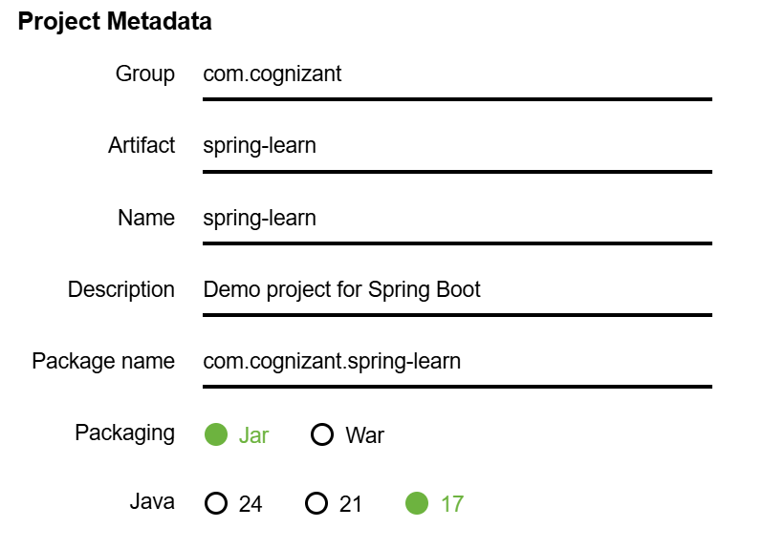

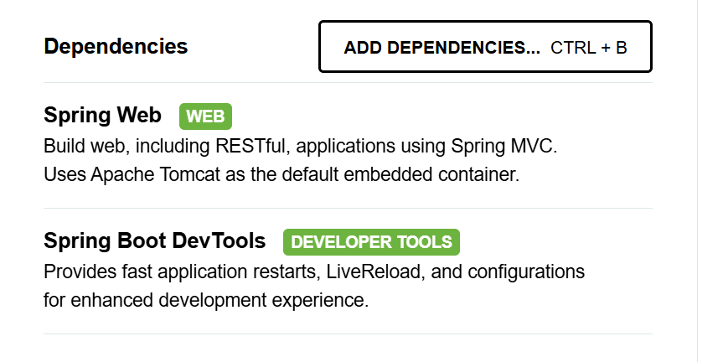

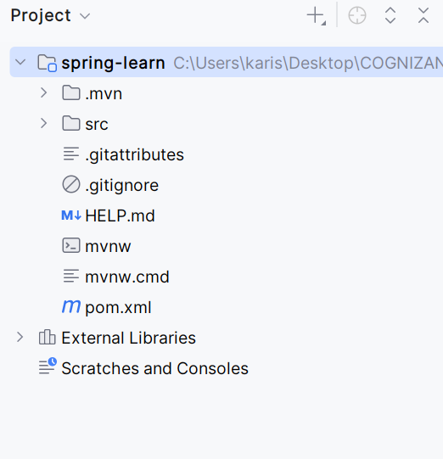

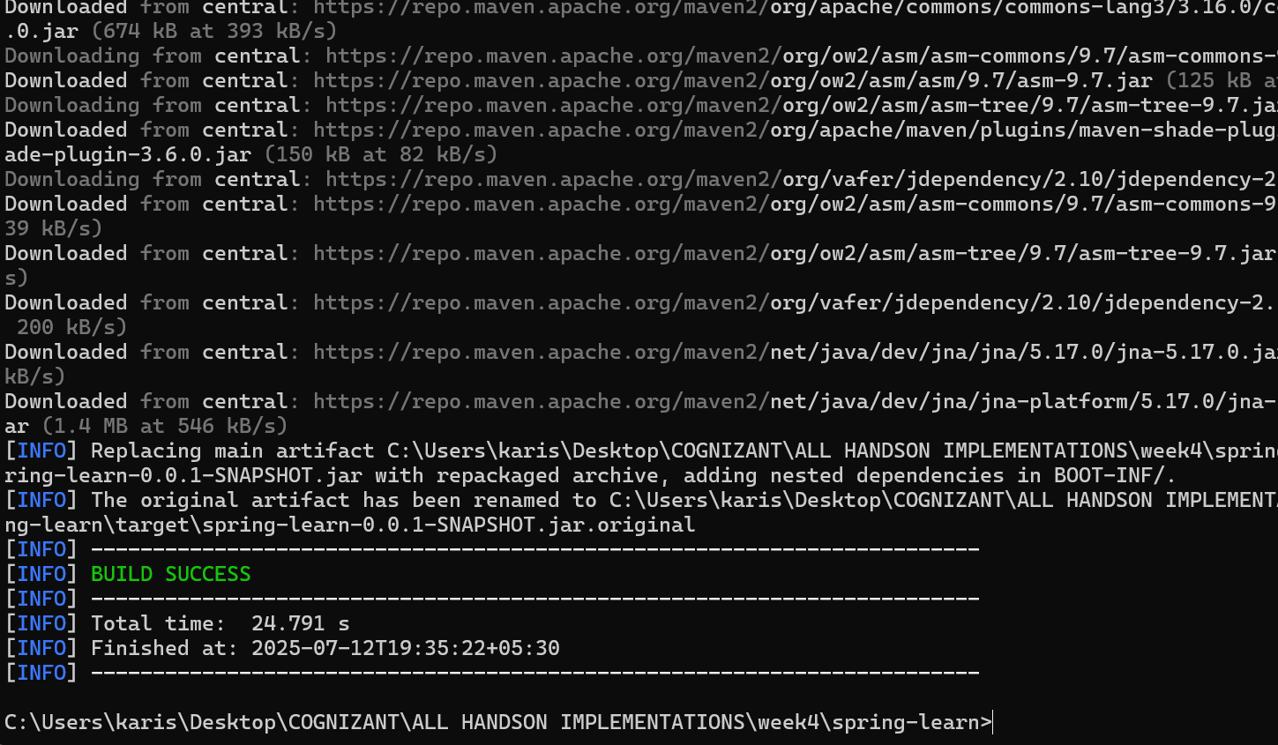

1. src/main/java - Folder with application code

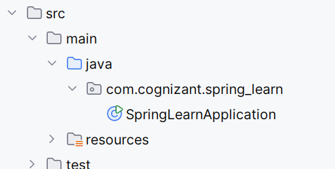

package com.cognizant.spring_learn;  
  
import org.slf4j.Logger;  
import org.slf4j.LoggerFactory;  
import org.springframework.boot.SpringApplication;  
import org.springframework.boot.autoconfigure.SpringBootApplication;  
  
@SpringBootApplication  
public class SpringLearnApplication {  
  
 private static final Logger *LOGGER* = LoggerFactory.*getLogger*(SpringLearnApplication.class);  
  
 public static void main(String[] args) {  
 *LOGGER*.info("START");  
 SpringApplication.*run*(SpringLearnApplication.class, args);  
 *LOGGER*.info("END");  
 }  
}

1. . src/main/resources - Folder for application configuration

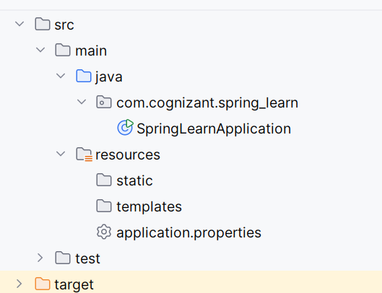

1. src/test/java - Folder with code for testing the application

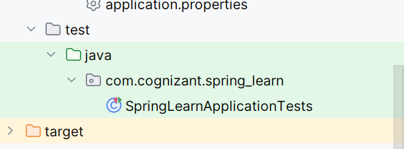

* 1. SpringLearnApplication.java - Walkthrough the main() method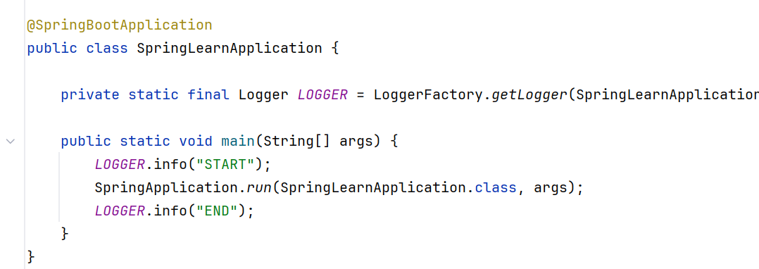

5.Purpose of @SpringBootApplication annotation

The @SpringBootApplication annotation is a **convenience annotation** in Spring Boot that is used on the **main application class** to bootstrap and launch a Spring Boot application.

6.Pom.xml :

*<?*xml version="1.0" encoding="UTF-8"*?>*<project xmlns="http://maven.apache.org/POM/4.0.0" xmlns:xsi="http://www.w3.org/2001/XMLSchema-instance"  
 xsi:schemaLocation="http://maven.apache.org/POM/4.0.0 https://maven.apache.org/xsd/maven-4.0.0.xsd">  
 <modelVersion>4.0.0</modelVersion>  
 <parent>  
 <groupId>org.springframework.boot</groupId>  
 <artifactId>spring-boot-starter-parent</artifactId>  
 <version>3.5.3</version>  
 <relativePath/> *<!-- lookup parent from repository -->* </parent>  
 <groupId>com.cognizant</groupId>  
 <artifactId>spring-learn</artifactId>  
 <version>0.0.1-SNAPSHOT</version>  
 <name>spring-learn</name>  
 <description>Demo project for Spring Boot</description>  
 <url/>  
 <licenses>  
 <license/>  
 </licenses>  
 <developers>  
 <developer/>  
 </developers>  
 <scm>  
 <connection/>  
 <developerConnection/>  
 <tag/>  
 <url/>  
 </scm>  
 <properties>  
 <java.version>17</java.version>  
 </properties>  
 <dependencies>  
 <dependency>  
 <groupId>org.springframework.boot</groupId>  
 <artifactId>spring-boot-starter-web</artifactId>  
 </dependency>  
  
 <dependency>  
 <groupId>org.springframework.boot</groupId>  
 <artifactId>spring-boot-devtools</artifactId>  
 <scope>runtime</scope>  
 <optional>true</optional>  
 </dependency>  
 <dependency>  
 <groupId>org.springframework.boot</groupId>  
 <artifactId>spring-boot-starter-test</artifactId>  
 <scope>test</scope>  
 </dependency>  
 </dependencies>  
  
 <build>  
 <plugins>  
 <plugin>  
 <groupId>org.springframework.boot</groupId>  
 <artifactId>spring-boot-maven-plugin</artifactId>  
 </plugin>  
 </plugins>  
 </build>  
  
</project>

**CREATED SPRINGBBOT MAVEN APPLICATION**